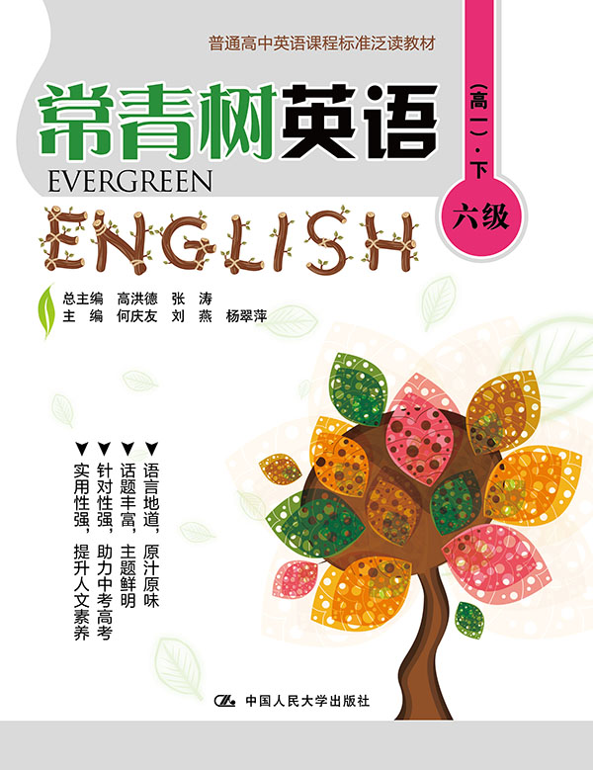
书名：常青树英语 六级（高一）·下
书号：978-7-300-21590-7
作者：高洪德 张涛 何庆友 刘燕 杨翠萍
责任编辑：鞠方安
成品：177*228 页数：250
纸张：70克高白胶
装祯：平装
出版时间：2015年9月
定价：43.00元
出版社：中国人民大学出版社

- 本书卖点
- 语言地道、原汁原味
- 话题丰富、主题鲜明
- 针对性强、助力中考高考
- 实用性强、提升人文素养

◆ 读者定位
高中生

- 作者简介
高洪德，山东省教学研究室英语教研员、特级教师，中国教育学会外语教学专业委员会副理事长、山东省教育学会外语教学研究专业委员会理事长。
张涛，山东省教育学会外语教学研究专业委员会秘书长、山东省教学研究室英语教研员。

- 内容简介
本册严格按照《普通高中英语课程标准》六至七级要求编写，适合高一年级学生阅读。全书五十余篇美文，来源于英、美、加、澳等国经典书刊、报纸、网站等各类媒体，经过数十位高中英语名师反复审读后选定，文章话题广泛、语言地道、内容丰富，兼顾了知识性和趣味性的结合，更特别注重了教化性。

◆ 简要目录
Lesson 1 Are You an Effective Learner?
Lesson 2 10 Ways to Improve Your Memory
Lesson 3 The Apple Tree
Lesson 4 Do You Exercise?
Lesson 5 The Best One
Lesson 6 Book, Ink, and Feather
Lesson 7 The Tale of Two Pebbles
Lesson 8 The Cave of Fear
Lesson 9 The Alphabet Of Happiness (Ⅰ)
Lesson 10 The Alphabet of Happiness (Ⅱ)
Lesson 11 I Am Me
Lesson 12 The Lost Necklace
Lesson 13 Be Careful with the Green-eyed Monster!
Lesson 14 Don't Hope,... Decide!
Lesson 15 Clever Dolphins
Lesson 16 Neighborhood Environment
Lesson 17 James Watt and the Teakettle
Lesson 18 No Greater Love
Lesson 19 Happy with What I Have
Lesson 20 A First for the First Lady
Lesson 21 The Reality of Success
Lesson 22 The Stinging Nettle
Lesson 23 Types of Relationships
Lesson 24 The Bitter and the Sweet
Lesson 25 If I Were a Boy Again
Lesson 26 The Panhandler's Box (Ⅰ)
Lesson 27 The Panhandler's Box (Ⅱ)
Lesson 28 Life Is like Boxing
Lesson 29 When Kids Stop Believing in Santa
Lesson 30 The True Spirit of Christmas
Lesson 31 Who Did Patrick's Homework?
Lesson 32 Here's How Much Your High School Grades Predict Your Future Salary
Lesson 33 Portrait of a Teacher
Lesson 34 President Obama Speaks on Death of Nelson Mandela
Lesson 35 The Remembrance of Lilacs
Lesson 36 Getting Started with TOEFL
Lesson 37 Dogs Understand Emotions like Humans
Lesson 38 A Gift of Love
Lesson 39 Do You Know Your Special Talent?
Lesson 40 How All Adults Make a Difference
Lesson 41 He Never Missed a Game
Lesson 42 Four Wives in Our Life
Lesson 43 The Mystery of the Mary Celeste
Lesson 44 The Riddle House (Ⅰ)
Lesson 45 The Riddle House (Ⅱ)
Lesson 46 Stand Tall like the Sunflower
Lesson 47 Robots as Fast as Cheetahs?
Lesson 48 Stonehenge
Lesson 49 All Flowers Are Beautiful
Lesson 50 The Chamois
Lesson 51 The Lion, the Witch and the Wardrobe (I)
Lesson 52 The Lion, the Witch and the Wardrobe (II)
Lesson 53 What American Hospitality Is About
Lesson 54 Unleashing Your Creativity
KEY

◆ 上架建议
中学英语泛读读本

书摘
Lesson 3 The Apple Tree
Guidance
Which of us can count what our parents have done for us? We can find the answer in the text. 我们中有谁能数的过来父母为我们做了什么？答案就在文章中。

A long time ago, there was a huge apple tree. A little boy loved to come and lay around it every day. He climbed to the tree top, ate the apples, took a nap under the shadow... He loved the tree and the tree loved to play with him.
As time went by, the little boy had grown up and he no longer played around the tree every day. One day, the boy came back to the tree and he looked sad. “Come and play with me,” the tree asked the boy. “I am no longer a kid; I don’t play around trees anymore.” The boy replied, “I want toys. I need money to buy them.” “Sorry, but I don’t have money...but you can pick all my apples and sell them. So, you will have money.” The boy was so excited. He grabbed all the apples on the tree and left happily. The boy never came back after he picked the apples. The tree was sad.
One day, the boy returned and the tree was so excited. “Come and play with me,” the tree said. “I don’t have time to play. I have to work for my family. We need a house for shelter. Can you help me?” “Sorry, but I don’t have a house. But you can chop off my branches to build your house.” So the boy cut all the branches off the tree and left happily. The tree was glad to see him happy but the boy never came back since then. The tree was again lonely and sad.
One hot summer day, the boy returned and the tree was delighted. “Come and play with me!” the tree said. “I am sad and getting old. I want to go sailing to relax myself. Can you give me a boat?” “Use my trunk to build your boat. You can sail far away and be happy.” So the boy cut the tree trunk to make a boat. He went sailing and never showed up for a long time. The tree was happy, but it was not true.
Finally, the boy returned after he left for so many years. “Sorry, my boy. But I don’t have anything for you anymore. No more apples for you.” the tree said.
“I don’t have teeth to bite,” the boy replied.
“No more trunk for you to climb on.”
“I am too old for that now,” the boy said.
“I really can’t give you anything... the only thing left is my dying roots,” the tree said with tears.
“I don’t need much now, just a place to rest. I am tired after all these years.” The boy replied.
“Good! Old tree roots are the best place to lean on and rest. Come, Come sit down with me and rest.” The boy sat down and the tree was glad and smiled with tears.
This is a story of everyone. The tree is our parent. When we were young, we loved to play with Mom and Dad. When we grew up, we left them, and only came to them when we need something or when we are in trouble. No matter what, parents will always be there and give everything they could to make you happy. You may think that the boy is cruel to the tree but that’s how all of us are treating our parents.
Take time out during the day for quiet time to listen to your inner voice. You may want to use your quiet time to meditate or pray. However you use this time, the key is to shut out all of the noise around you by focusing deep within yourself. Breathing deeply during quiet time will also help you focus. I know it’s hard to find quiet time during a particularly busy day, but it’s so important—even if it’s just 10 minutes a day and you have to sneak away to get it. Quiet time can really make a difference in your life. It enables you to hear God speaking to your heart reminding you of his perfect love for you.
Despite what your subconscious may be telling you, you can have love with no limits. The key is to unconditionally love yourself first.

